Flex
- Introduction
Flexbox is a one-dimensional layout that can lay out elements either horizontally or vertically (but not both). An element using flexbox as its layout is referred to as a flex container, and the elements inside it are flex items.
- Flex container
To transform one element into a flex container, change display CSS property to flex or inline-flex. Then, all direct child elements become flex items.
- Direction and axis
A flex container has a direction, defined by the flex-direction property. It can be either a row (horizontal) or column (vertical). The flex container consists two perpendicular axes. The main-axis follows the direction declared in flex-direction while the cross-axis points perpendicular to it.
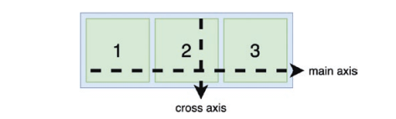
Figure 1.1: The main axis and the cross axis.

- Handle flex items alignment
We can apply justify-content and align-items to manage how flex container organize its flex items across both its two axes.
justify-content is responsible for aligning item along the main axis All valid values for justify-content are showed in the table below:
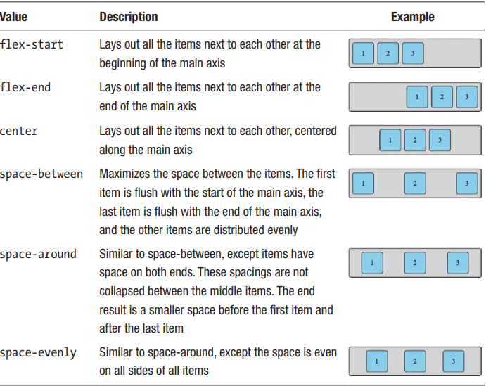
The align-items property is also set on the container. It controls how flex items are aligned along the cross axis. The default value is stretch, which will stretch items along the cross axis to fill the container’s size, while respecting height and width constraints. The different options for align-items are shown in table:
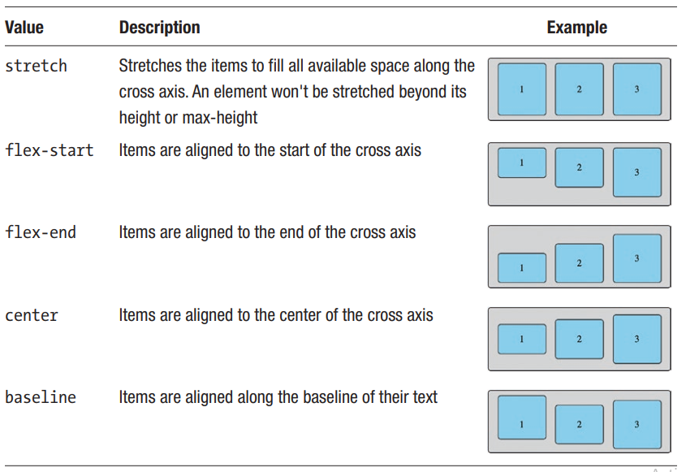
Note: all the examples listed in two table assume that the main axis of flex container is horizontal.
Tip: center one element inside flex container.
.container {
display: flex;
justify-content: center;
align-items: center;
};

- Control flex items size
By default, item w
- flex-shrink
The flex-shrink property specifies the amount of shrinking that can be done to a flex item relative to the other items. This defaults to 1, which is why all of the elements were shrunk evenly.
- flex-grow
By default, if the items are not large enough to fill the container, there will be empty space. This behavior can be controlled with the flex-grow property, which is set on the flex item rather than the container. Initially, this is 0, which means the items won’t grow at all. flex-grow is a relative measure. If all of the items are set to flex-grow: 1, they will all grow equally to fill the space.
- flex-basis
The flex-basis property sets the initial size of a flex item along the main axis before flex-grow and flex-shrink factors are applied.
flex-wrap.

